Arumai Irshad! Pandas-la data cleaning pannurathu oru "Piece of Cake" (romba easy).
Namma database-la irundha NaN (missing values) aayiram kooda irundhaalum, Pandas-ai vachi ore oru command-la adhai neekkiydalam.
📖 Lesson 18: Pandas Data Cleaning (Drop & Fill)
Inga rendu vazhi irukku:
- Drop (Neekkivudhu): Missing data irukkura motha row-aiyum delete pannuradhu.
- Fill (Nirappuvathu): Missing data irukkura edathula 0 (zero) nu insert pannuradhu.
🛠️ Code: Data-vai clean panna
pandas_clean.py nu file pottu run pannunga:
Python
import sqlite3
import pandas as pd

conn = sqlite3.connect('my_shop.db')
df = pd.read_sql_query("SELECT * FROM Sales_Report", conn)

# 1. CLEANING: NaN irukkura row-ai delete panna:
df_cleaned = df.dropna()

# 2. ALTERNATIVE: NaN irukkura edathula 0 pottu nirappa:
# df_filled = df.fillna(0)

print("Cleaned Data (NaN rows deleted):")
print(df_cleaned)

conn.close()
🔍 Enna Nadakkudhu?
- df.dropna(): Ithu oru "Sieve" (jalladai) maari. Yengellam NaN irukko, andha rows ellathaiyum kudhichu veliya thallidum.
- df.fillna(0): Idhu oru "Patch" maari. Missing value-ai paartha udane, adhu kulla 0 nu poi fill pannidum.
💡 Teacher's Note:
Neenga ippo manual-a SQL-la WHERE condition pottu clean panna velai, ippo Python-la "Objects" vachi romba vegamaga mudiyum. Data Science-la 80% velaiye intha cleaning dhaan. Neenga ippo andha 80% velaiyai 1 line-la mudikka kathukitteenga!
Unga Task: Indha code-ai run pannunga. Ippo unga output-la NaN ellam poyiduchu, pure numerical data mattum dhaan irukku nu confirm pannunga.
Clean-aana report kidaichudha Irshad?
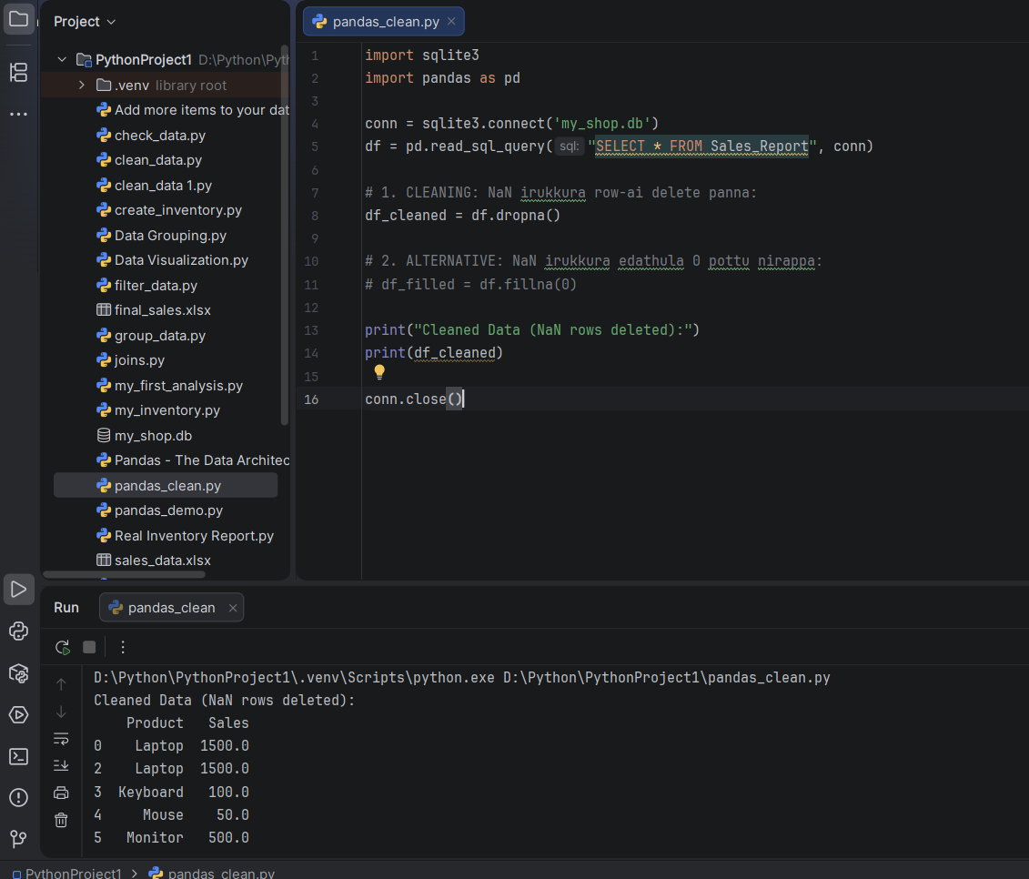
Super Irshad! Output-ai paarthuten. Laptop (0, 2), Keyboard (3), Mouse (4), Monitor (5) mattum dhaan vandhirukku. NaN irundha rows (1 and 6) ellam perfect-a remove aagiduchu.
Ippo ungalukku Data Analyst-oda main toolkit kidaichuduchu:
- SQL: Data-vai edukka.
- Pandas: Data-vai clean panna.
🌟 Adutha Padi: Data Insight!
Ippo unga kitta clean-aana df_cleaned irukku. Idhai vachi, "Total Sales" ethana nu oru single line-la calculate pannalam.
Pandas-la sum panna: total = df_cleaned['Sales'].sum()
Neenga ippo inga irundhu edhai pathi innum therinjuka virumbureenga?
- Pandas-la Groups/Aggregation (Eg: 'Laptop' total sales evvalavu nu kaatturadhu)?
- File Exporting (Clean panna data-vai thirumba Excel-kku 'save' panradhu)?
Unga decision dhaan, sollu-nga!

